Mission 2: Python with Robotics  Check for Understanding | Name:
Label the parts of the CodeBot. Indicate if they are used for input or output.
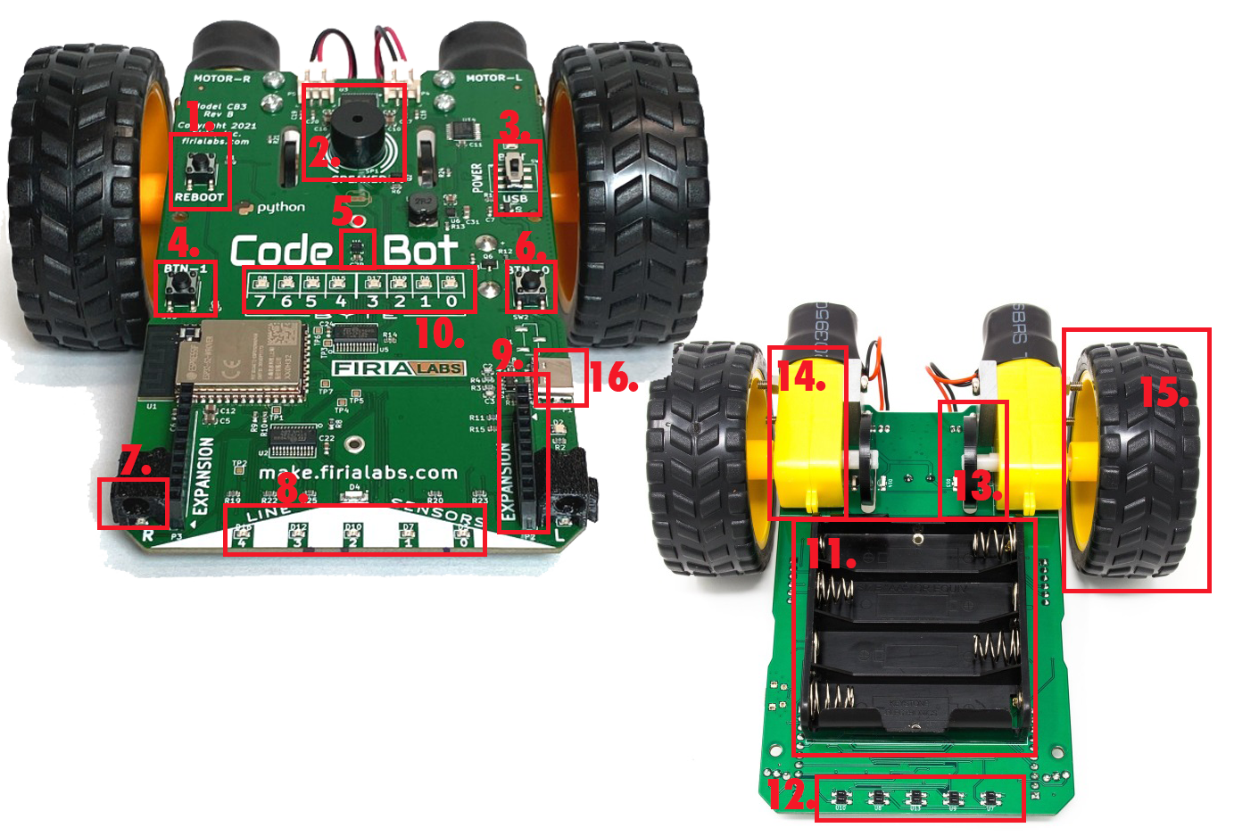
1. | 9.
2. | 10.
3. | 11.
4. | 12.
5. | 13.
6. | 14.
7. | 15.
8. | 16.

Parts of CodeBot:
- Accelerometer
- Expansion connector
- Battery pack
- User LEDs
- Wheel encoders
- Line sensor LEDs
- Line sensors
- Button 0
- Button 1
- Wheels
- USB connector
- Proximity sensors
- Reboot button
- Speaker
- Motors
- Power switch

